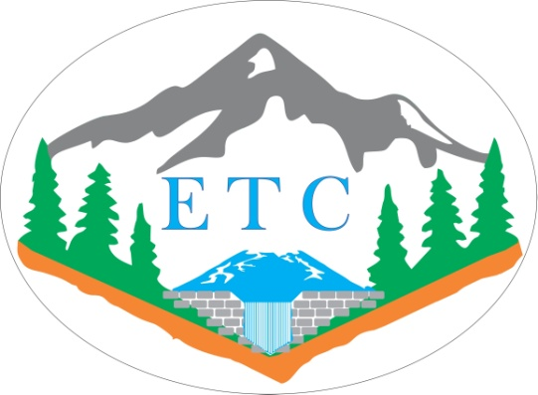
1st Young Researchers’ Conference - Erosion and Torrent Control
ETC 2018
BELGRADE, 28-30 NOVEMBER 2018


1st Young Researchers’ Conference - Erosion and Torrent Control
ETC 2018
BELGRADE, 28-30 NOVEMBER 2018

REGISTRATION FORM

Name
Date of Birth
Organization
Address
Phone
Fax
E-mail

I am interested in:

- Attending the Conference
  - 1 day
  - All 3 days
- Presenting a paper entitled:

