TITLE (TIMES NEW ROMAN, BOLD, 12PT, CAPS LOCK, CENTER ALIGNMENT)
Author’s full name, First author¹*, Second¹, Third²… (Times New Roman, Regular, 12pt, center alignment)
¹Organization (Times New Roman, Regular, 12pt, center alignment)
²Organization (Times New Roman, Regular, 12pt, center alignment)
e-mail of the first author whose name will be marked by *

ABSTRACT: Paper format A4, margins (top 2cm, bottom 2cm, left 2 cm, right 2cm), Times New Roman, Regular, 10pt, alignment justified, line spacing single. Abstract is should have 400 words or less.
Key words: 5 or less, Times New Roman, Regular, 10pt, alignment justified
Paper structure (Paper format A4, margins (top 2cm, bottom 2cm, left 2 cm, right 2cm), Times New Roman, Regular, 10pt, alignment justified, line spacing single), number of pages up to 8 (max 10, if necessary):
- Introduction
- Material and Methods
- Results and Discussion
- Conclusion
- References
Table 1. Times New Roman, Regular, 9pt, center alignment
Source: Times New Roman, Regular, 9pt, center alignment

Figure 1. (Times New Roman, Regular, 9pt, center alignment) Hoodoos
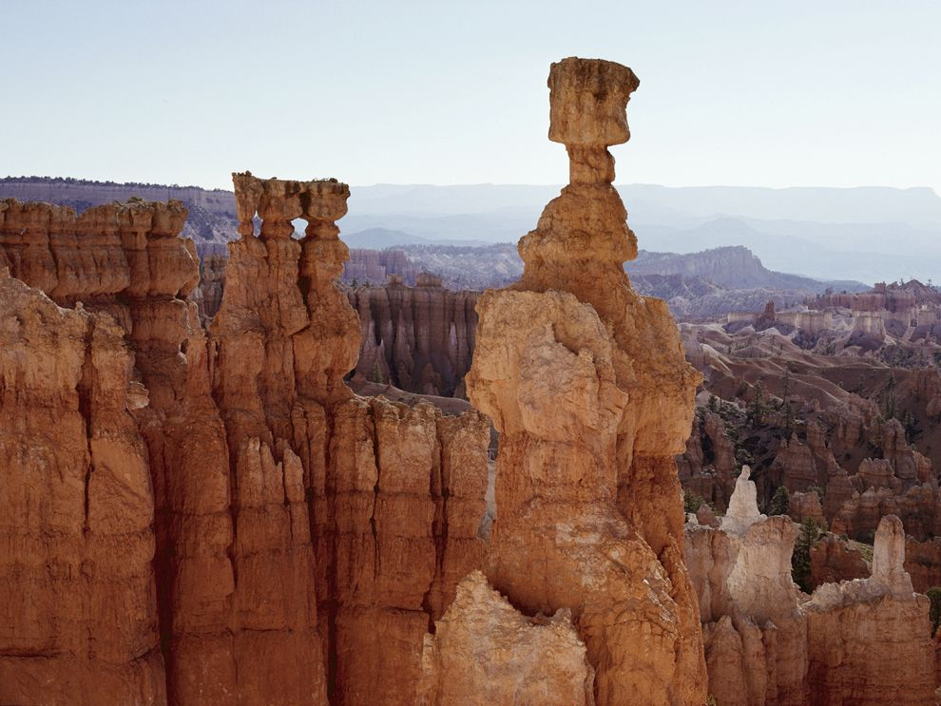
Source: (Times New Roman, Regular, 9pt, center alignment) Photograph by George F. Mobley

